Medical Insurance

Python.file:

Screenshot:
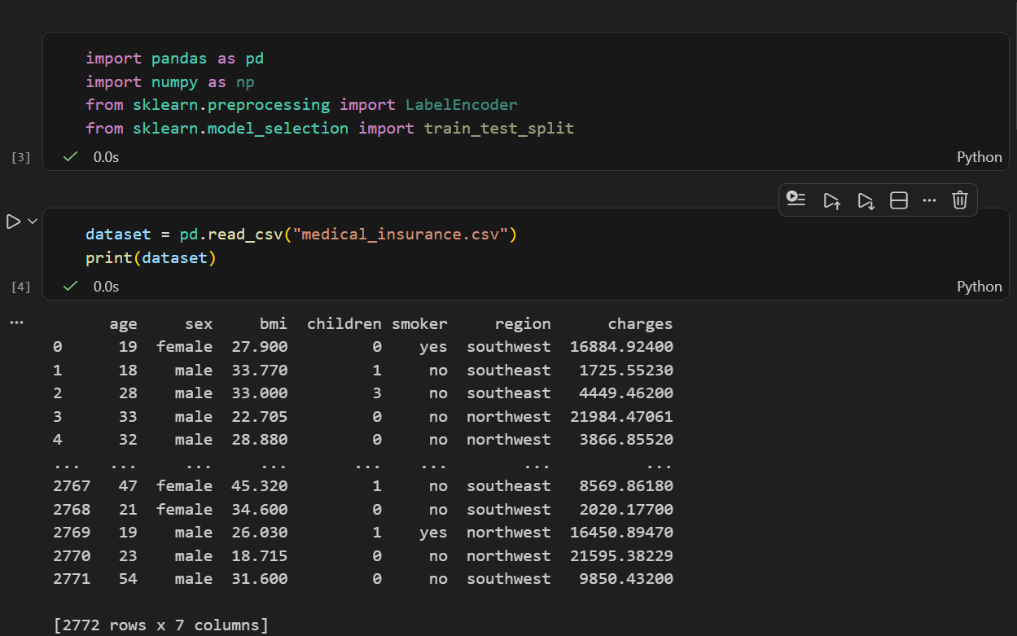

Kaggle File:

Details:
- Imported Required Libraries: pandas, numpy, and scikit-learn (LabelEncoder and train_test_split)
- Loaded Data: Read the medical_insurance.csv file into a pandas DataFrame
- Data Display: Printed the complete dataset to view all records
- Data Inspection: Displayed first 5 rows (head()) and last 5 rows (tail()) of the dataset
- Data Shape Analysis: Checked the number of rows and columns in the dataset
- Missing Values Check: Verified the presence of null values across all columns
- Missing Values Summary: Generated a count of missing values per column
- Data Type Check: Identified the data types of each column in the dataset

